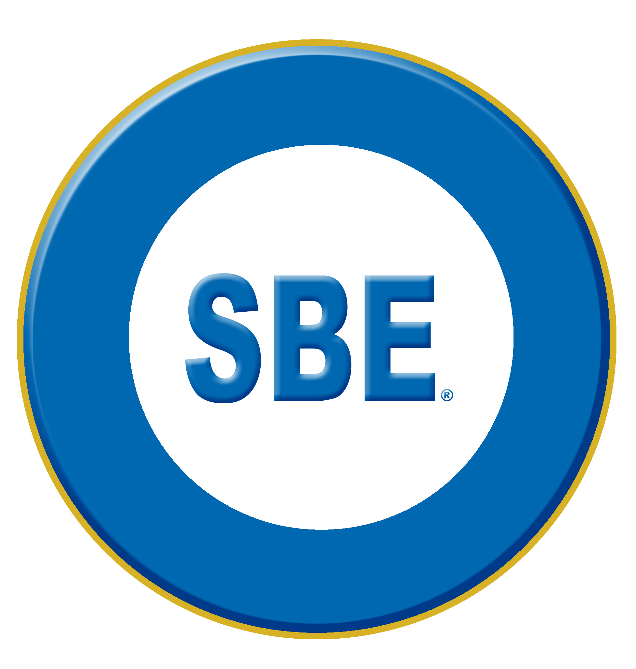

NEWS RELEASE
Contact: Chriss Scherer, Member Communications Director, SBE cscherer@sbe.org
For Immediate Release

SBE and ATSC to Develop ATSC 3.0 Certification for Broadcast Engineers
May 23, 2018 - Washington, DC - The Society of Broadcast Engineers, Inc. (SBE), the association for broadcast and multimedia technology professionals, and the Advanced Television Systems Committee, Inc. (ATSC) today announced a cooperative effort to develop a new Specialist level of SBE certification that will benchmark an individual's proficiency in the ATSC 3.0 System standard.
"SBE Certification covers a range of experience levels and disciplines in broadcast and media engineering. As broadcast engineering diversified beyond legacy technology, the SBE Certification Program also diversified by adding certifications for computer networking and IT, and then a series of specific Specialist Certifications for television transmission, AM directional arrays, and digital radio. With the industry preparing to implement ATSC 3.0, broadcast engineers must be proficient in the next-generation television technology. The SBE and ATSC are working together to develop the next SBE Certification Specialist to cover ATSC 3.0," said SBE President Jim Leifer, CPBE.
"ATSC is pleased to work with SBE to develop an ATSC 3.0 Specialist Certification program. The SBE has extensive experience training and certifying broadcast engineers. Our work with the SBE is part of efforts to support deployment of ATSC 3.0," said Mark Richer, president of ATSC.
The world's first internet-based broadcast television standard, ATSC 3.0 will give stations and viewers more choices and options now that broadcast TV can seamlessly connect with broadband-delivered content. Approved for use by U.S. broadcasters and deployed in South Korea, ATSC 3.0 technologies make it possible to transmit in Ultra High-Definition, to offer immersive audio, and to add more capabilities like high dynamic range, wide color gamut, and interoperability with Internet-delivered content.
The Society of Broadcast Engineers Certification Program is part of the society's efforts contributing to the advancement of broadcast engineering for the general benefit of the entire broadcast industry. The program was created in 1975 to recognize and raise the professional status of broadcast engineers by providing standards of professional competence. Through the years, the SBE's certification program has become recognized in the industry as the primary method of verifying the attainment of educational standards. With the industry constantly changing, the SBE-certified engineer must keep up with those changes.
To hold SBE Specialist Certification, an individual must first hold one of the SBE core-four certifications: CBT, CBRE/CBTE, CSRE/CSTE or CPBE. Once the new Specialist Certification is released, applicants will take a 50-question, multiple-choice exam and answer an essay question.
More information about SBE certification is online at sbe.org/cert.
# # #

About the Society of Broadcast Engineers: The SBE is the professional organization of television and radio engineers and those in related fields. The SBE has more than 5,000 members in 114 chapters across the United States and in Hong Kong. There are also members in more than 30 other countries. Most chapters meet monthly and offer educational programs and an opportunity to network with other broadcast technical professionals. SBE offers the preeminent technical broadcast certification program in the U.S. and an expansive list of educational programs for broadcast engineers, operators, technicians, and broadcast IT professionals.
For more information about the SBE, contact John L. Poray, CAE, Executive Director, at jporay@sbe.org or 317-846-9000, or visit the SBE website, www.sbe.org.

About the ATSC: The Advanced Television Systems Committee is defining the future of television with the ATSC 3.0 next-generation broadcast standard. ATSC is an international, non-profit organization developing voluntary standards for digital television. The ATSC’s 150-plus member organizations represent the broadcast, broadcast equipment, motion picture, consumer electronics, computer, cable, satellite, and semiconductor industries. For more information visit www.atsc.org.

Note: All SBE certifications and certification abbreviations are trademarks of the SBE.

