SOCIETY OF BROADCAST ENGINEERS, INC.
The Association for Broadcast and Multimedia Technology Professionals
9102 N. Meridian Street, Suite 150, Indianapolis, IN 46260
317-846-9000

NEWS RELEASE
Contact: Chriss Scherer, Member Communications Director
For Immediate Release cscherer@sbe.org

Society of Broadcast Engineers Presents John H. Battison Award for Lifetime Achievement to Mark Persons
September 25 2020, Indianapolis, IN – The Society of Broadcast Engineers presented its Membership Meeting & Awards Presentation (MMAP) webcast on Sept. 23. The program, held online after the in-person events had to be cancelled because of COVID-19, combined the SBE's annual Membership Meeting and Awards Banquet presentations into one online event.
In addition to the previously announced awards, including the Robert W. Flanders SBE Engineer of the Year award to RJ Russell, CPBE, of Middletown, DE, and the 2020 James C. Wulliman SBE Educator of the Year awards to Fred Baumgartner, CPBE, CBNT, of Elizabeth, CO, and Roland Robinson, CBTE, CBNT, CTO, of Tacoma, WA, the event also recognized other individual and chapter efforts, as well as the two newest SBE Fellows, Ralph Beaver, CBT, and Jim Leifer, CPBE.
The MMAP also added a special surprise event. The SBE John H. Battison Award for Lifetime Achievement recognizes and pays tribute to individuals for their dedication, lifelong achievement and outstanding contribution to broadcast engineering. Nominees are SBE members in good standing and have been active for 40 years or more in the broadcast engineering industry or a closely allied field that benefits broadcast engineering. Nominations can be made by any member of the SBE and will include the endorsement of three other SBE members. There is no more than one recipient per calendar year. The recipient for 2020 is Mark Persons, CPBE, AMD, CBNT.
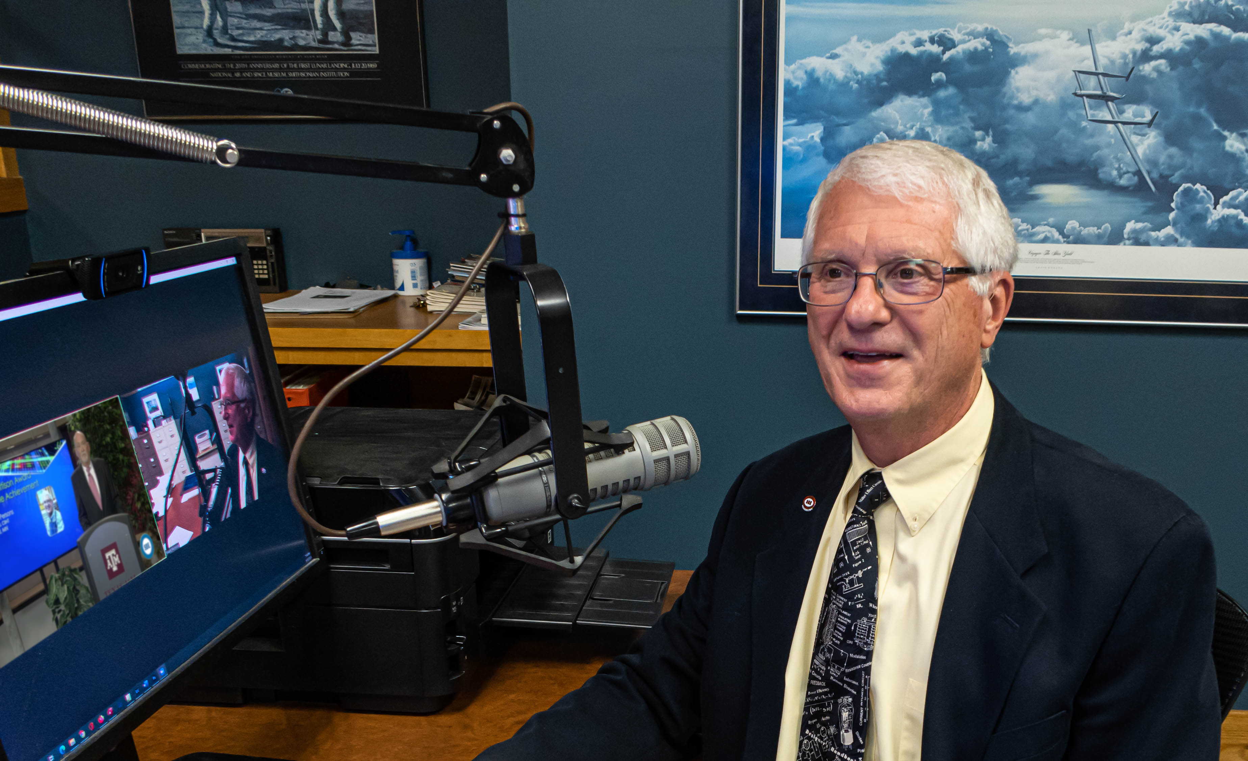
Mark, a life-long resident of Minnesota, followed in the footstep of his father, who was also a radio broadcast engineer. Mark started turning transmitter knobs more than 60 years ago.
While reaching the rank of sergeant in the United States Army from 1967 to 1969, Mark was in charge of an avionics repair shop for the OV-1 Mohawk high-tech surveillance aircraft in Vietnam. After his military service, he spent the next ten years with KVBR radio in Brainerd, MN, where he became chief engineer. In 1977, he opened his own radio engineering consulting business, which he operated for the next 40 years. He married his wife Paula in 1978, and she became instrumental in running the business side of the business out of their home.
Mark has been a respected engineer in Minnesota and the upper Midwest his entire career. He built 12 commercial AM and FM radio stations, and rebuilt, upgraded, maintained and repaired countless other radio stations for clients. He has endeavored to share his knowledge and experience with others in the field. He has written more than 140 articles that have appeared in industry magazines and made more than 25 speeches and presentations at industry conventions, conferences and meetings.
Mark joined the SBE in 1981, and is now a life member. He holds three life certifications from the SBE. Outside of his broadcasting career, Mark is a member of the American Legion, The VFW and Disabled American Veterans. He enjoys amateur radio as WØMH, and photography.
Retired several years ago, he and Paula are mentoring younger broadcast engineers through the SBE Mentor Program. Mentoring is his way of giving back to the industry that kept him employed for more than 50 years.
On receiving the honor during the webcast, Mark said, "This really was a lifetime experience for me. I never had a plan B. I was always going to be a broadcast engineer, and that's exactly how it came out. I want to continue to contribute to the Society of Broadcast Engineers. Thank you."
More information about the award is online: sbe.org/membership-directory/awards_lifetime.php

About the SBE
The Society of Broadcast Engineers (SBE), a non-profit, professional organization formed in 1964, is devoted to the advancement of all levels and types of broadcast engineering. Operating from our national headquarters in Indianapolis, Indiana, SBE is a chapter-based membership association with approximately 5,000 members and 114 local chapters nationwide.
For more information about the SBE, contact John L. Poray, CAE, Executive Director, at jporay@sbe.org or 317-846-9000, or visit the SBE website, www.sbe.org.
# # #

Editors:
High-resolution image of Mark receiving the news of the award:
http://sbe.org/images/hirez/PersonsReceivesBattisonAward.jpg

