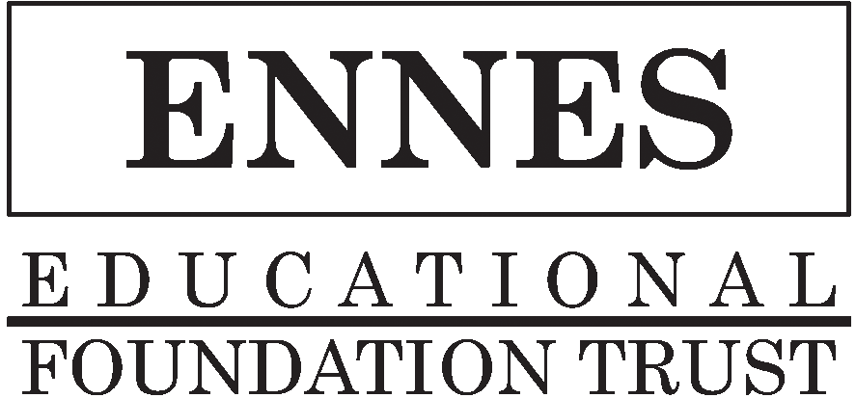
Hosting an Ennes Workshop

Overview
Ennes Workshops typically cover a range of topics in one day (app. 9:00 a.m.-5:00 p.m.) and have part of the day devoted to separate seminar tracks for radio and TV topics. Our Ennes Moderator and program organizer is SBE Member Fred Baumgartner.

The major responsibilities for a hosting chapter are to promote the program HEAVILY among local members, stations, colleges, etc. and also work with SBE staff to locate the ideal hotel or other facility to have the program. It needs to be reasonably priced and of at least moderate quality, easily accessible by car with free parking. Finding a facility close to an airport helps, since many of the speakers will be from out of town. Broadcast facilities can be used if they have the capacity and allow us to contract with an outside caterer.

Attendance
We like to have a minimum of 50 people in attendance and typically will have 60 to 80. Our experience has been that about 65% of the attendees come from the local host chapter’s area. The rest drive in from as many as four hours away.

Expenses
There are expenses involved in organizing an Ennes Workshop. The cost largely depends on what's provided and the number of people expected to attend.

Expenses may include:
- Function space at a venue - typically we do these in a hotel rather than a station or other setting because of the staff support and food and beverage availability on site. But a station can work
- Food and beverage - may include coffee, juice and a breakfast item in the morning and coffee and soda in the afternoon. Lunch is provided as well.
- Audiovisual equipment - sometimes provided by local members for free, otherwise rented from the hotel
- Event promotion - printing, postage and mailing of two flyers from the SBE National Office to SBE members within a three hour or so drive from the Workshop location
- Travel expenses - for the volunteer moderator (Fred) and one SBE staff member who handles on-site check-in, coordinates with the venue and supports Fred and the speakers
- Other deliverables - certificates of completion and packets for attendees and small gifts for the volunteer speakers

Determining Registration Pricing
We like to set up a member and non-member price structure so members get a discount. Typically, chapters have chosen to keep the fees low to make it easier for more people to attend. Anywhere from $25 to $69 has been charged in recent years.

However, the revenue from the registration alone will not cover all of the expenses. So, sponsors, which are mainly manufacturers and/or the chapter itself (and sometimes a state broadcasters association), are recruited to subsidize the program. The SBE National Office will work with the host chapter to arrange sponsors if necessary. Once the Chapter and SBE National Office have settled on what will be provided, National Office staff will draft a budget for the program.

Assignment of Responsibilities
SBE National/Ennes will take care of arranging the Workshop program; design, produce and mail the two flyers, provide the on-site moderator and staff support and contract and work with the hotel on meeting arrangements. National will also handle all registrations using our website-based online automated system, provide name tags, promote the program on the SBE website, SBE Signal, etc. Credit card payments would be accepted for registration as well as personal or company checks.

The local chapter may choose to sell table-top display “booths” to vendors to help offset the cost of the Workshop. This will require additional space and other considerations and should be discussed at the beginning of the planning stage. It is a good way to offset much of the costs of the program if other means do not.

Timeframe for Holding this Program
Our "windows of opportunity" include January through early March; mid-May through June and August through early November. Most Ennes Workshops are held on weekdays but they may also be held on a Saturday.

We request at least 90 days advanced planning and promotion time prior to the event.

Schedule a Workshop
Contact the SBE Education Director, Kristin Owens, at (317) 846-9000 or via email at kowens@sbe.org.

Page 2 of 2

